Below we can see the screenshot of my “login.ejs” file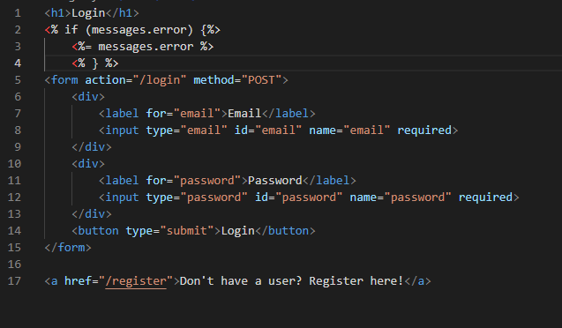

Here is what it looks like in the browser

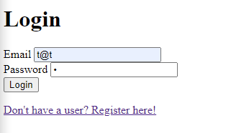

Have also implemented error messages when email or password are incorrect

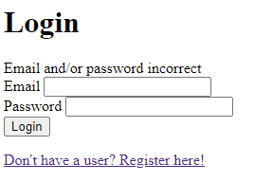

Below is a screenshot of the login in function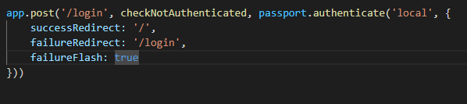

As you can see the login function uses a variable called passport with a function called authenticate.

the whole login process is used through a function called initiate, that is on an other file called “passportConfig.js”. Below is a screenshot of this file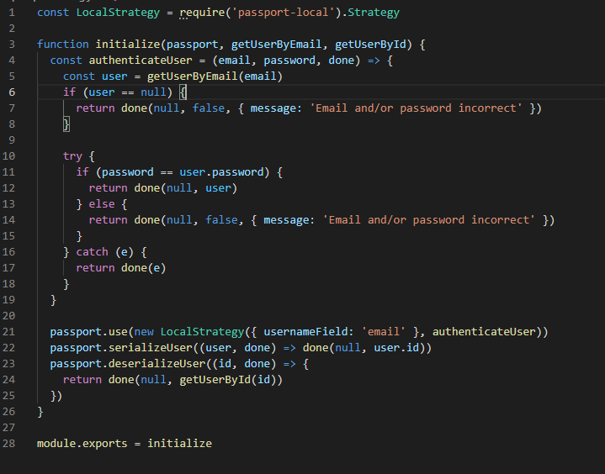

if the login is successful, then the user is redirected to the homepage, which is the file “index.ejs”. this is what the page looks like at this stage of development (second commit on the register and login branch)

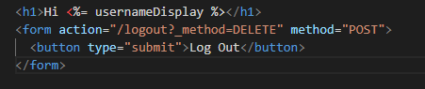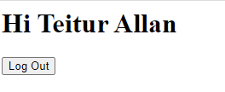

A screen recording of me showing that the login function, the log out function and the persistent login functions work, is in the foulder with the path “C:\Users\Teitur\Desktop\CBS_notater\1_semester\Programmering\EksamensOpgaveSemester1\test screenshots\Login with persistant login “